**Docker Task -3**

**Task Description:**

Create a custom docker image for nginx and deploy it using docker compose, where the volume bind mount should be at /var/opt/nginx location. Push the created custom docker image to your docker-hub.

Explanation:

1. In AWS, launch an EC2 instance.

Login to AWS console, In EC2 dashboard, click launch instance.

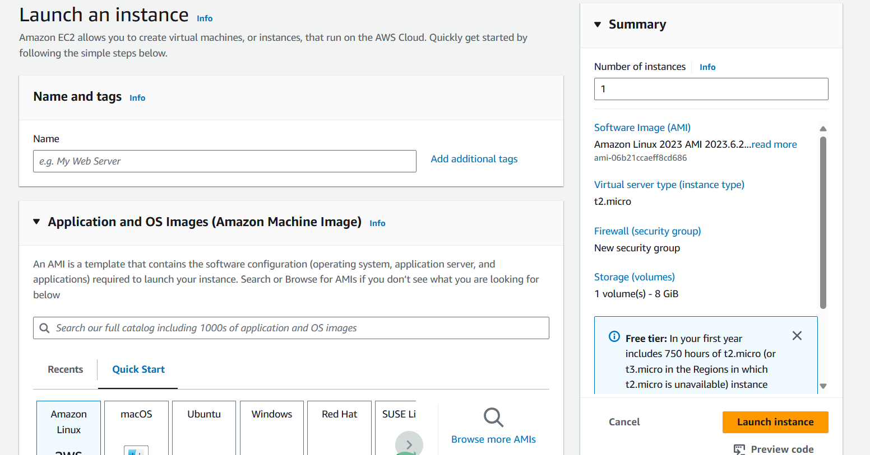

Choose an Amazon Machine Image (AMI)- Ubuntu-based image

Choose an Instance Type - t2.micro

Review and Launch the instance.

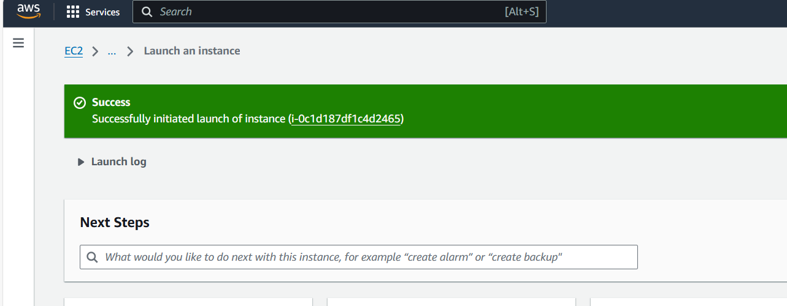

1. Connect to EC2 instance.

Once the instance is running, click View Instances.

Select the instance,click on Connect.

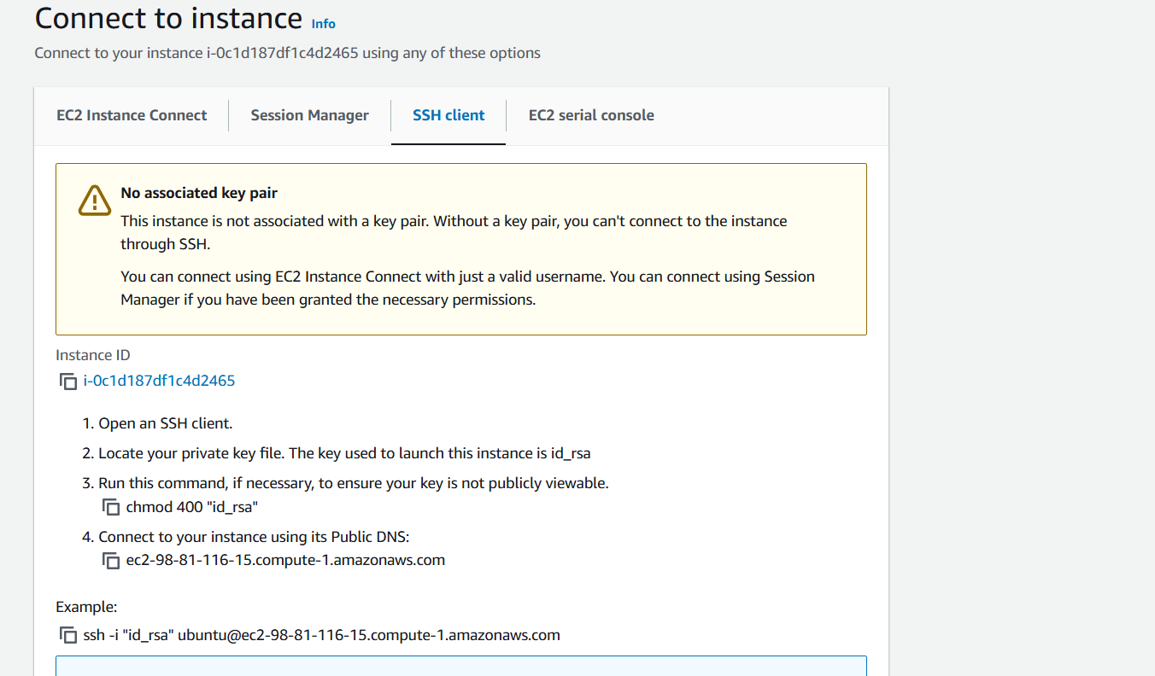

Use the SSH client tab instructions to connect to the instance using a terminal.

Open VS Code editor, and use ssh to connect to the EC2 instance.

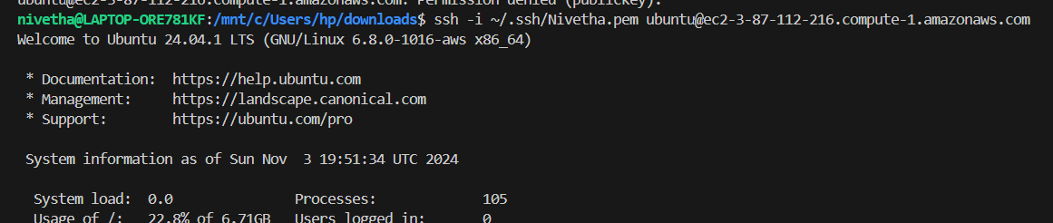

1. Install Docker on EC2 instance.

Update package using sudo apt update && sudo apt upgrade -y

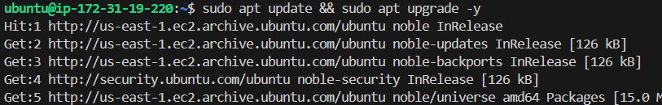

Install docker using sudo snap install docker

Start the docker using sudo snap start docker

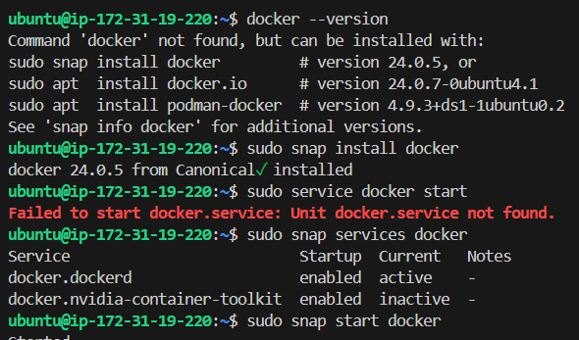

Create the Docker Group using sudo groupadd docker

Add the user into group using sudo usermod -aG docker ubuntu

Verify the group using getent group docker

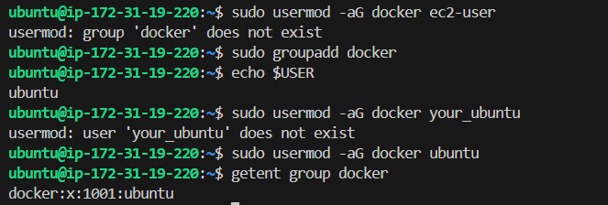

1. Install Docker compose

$ sudo curl -L "https://github.com/docker/compose/releases/latest/download/docker-compose-$(uname -s)-$(uname -m)" -o /usr/local/bin/docker-compose

sudo chmod +x /usr/local/bin/docker-compose

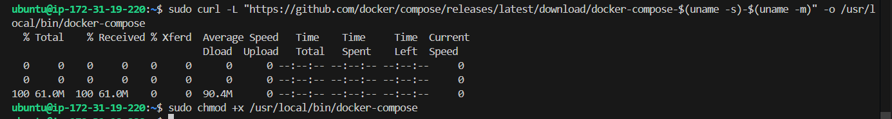

1. Create NGINX Docker Image

Command: mkdir nginx-docker && cd nginx-docker

create docker file using nano Dockerfile



Add content as below

FROM nginx:latest

COPY index.html /usr/share/nginx/html/index.html

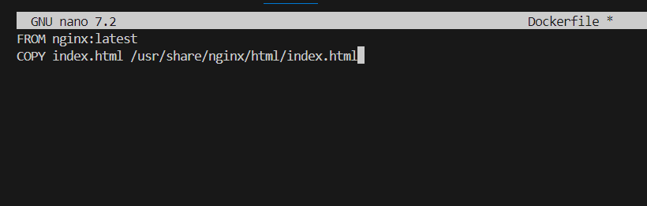

Create index,html file using nano index.html



Add the content as below

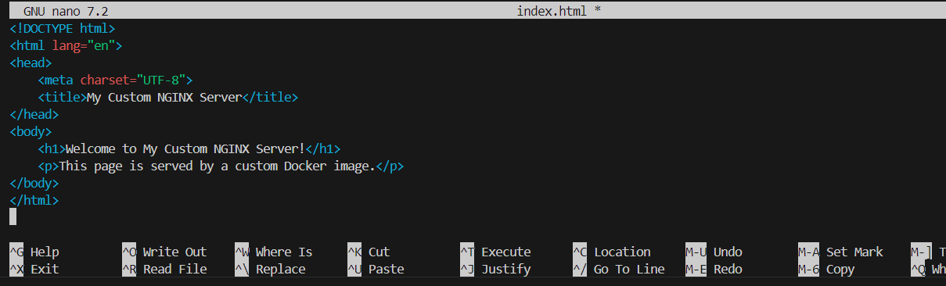

Build the docker image using

sudo docker build -t ubuntu/custom-nginx .

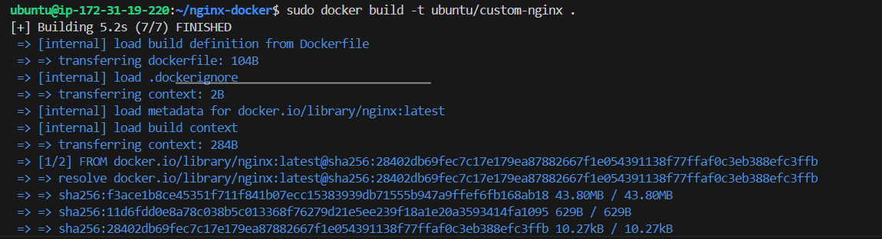

1. Push the docker image to docker hub

Login to docker using sudo docker login

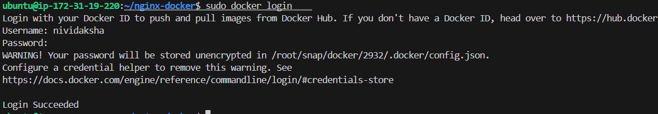

Push the docker image using sudo docker push nividaksha/custom-nginx

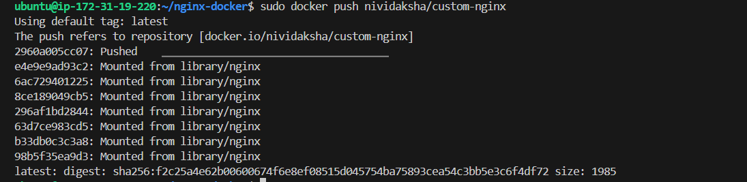

1. Create Docker compose file

Command : nano docker-compose.yml



Add the following contents

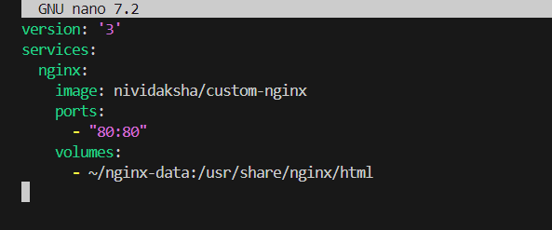

1. Run the docker compose file

Create the directory on EC2 instance using mkdir -p ~/nginx-data



Start the container using sudo docker-compose up -d

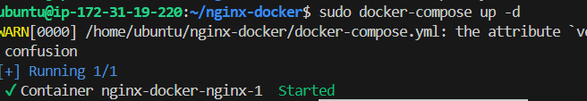

Verify the container using sudo docker ps



1. Deployment testing

Verify by copying the public ip address in the ec2 console.

